Audio Effect Generator

By: Amit Singha

**It is time to say Bye bye to boring Music!!**

Yes, we are introdusing the new Audio Effect Genarator to

Revolutionize your audio mixing experience.

**What are the possibilities?**

You can use our product to generatae the following effects:

-Echo

-Tremolo

-Slap Back

-Chorus

-Panning

-Reverb

Every one is a music lover, what if you get a chance to create

Your own music with this simple device..Yes we offer you the same.

**Multiple input type..** **Real Time action !!**

You can use pre recorded audio throgh the Aux input

Or You can directly use the in built mic for processing the audio.

**Simple design..Ease of usage.** 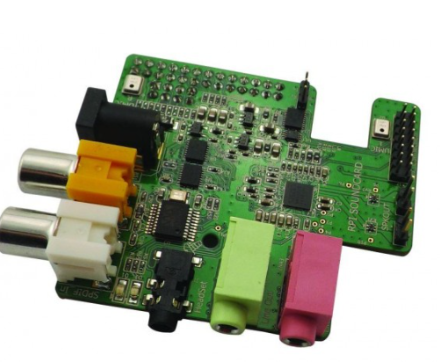

Yes you heared it right, our product is built using simple hardware

Just requires Wolfson pi audio card and FRDM-K64F board.

